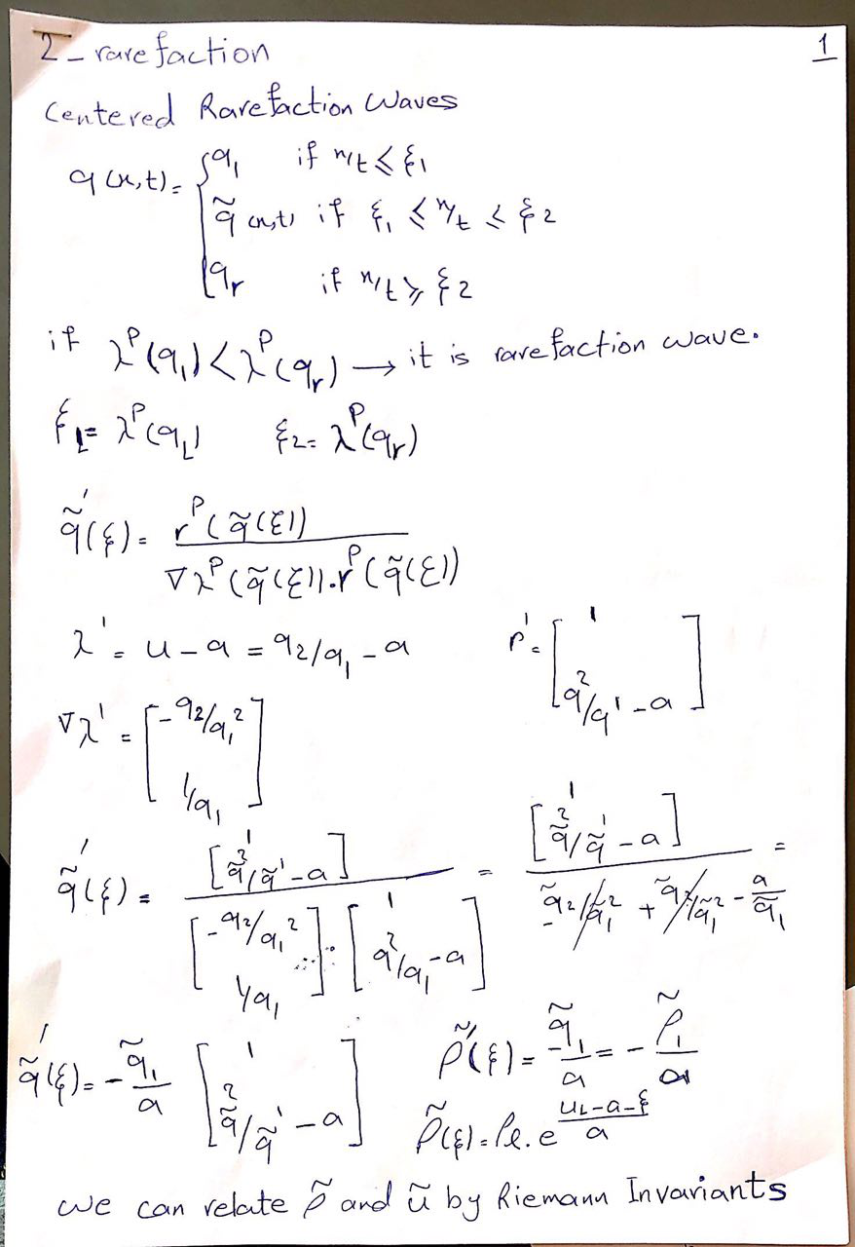

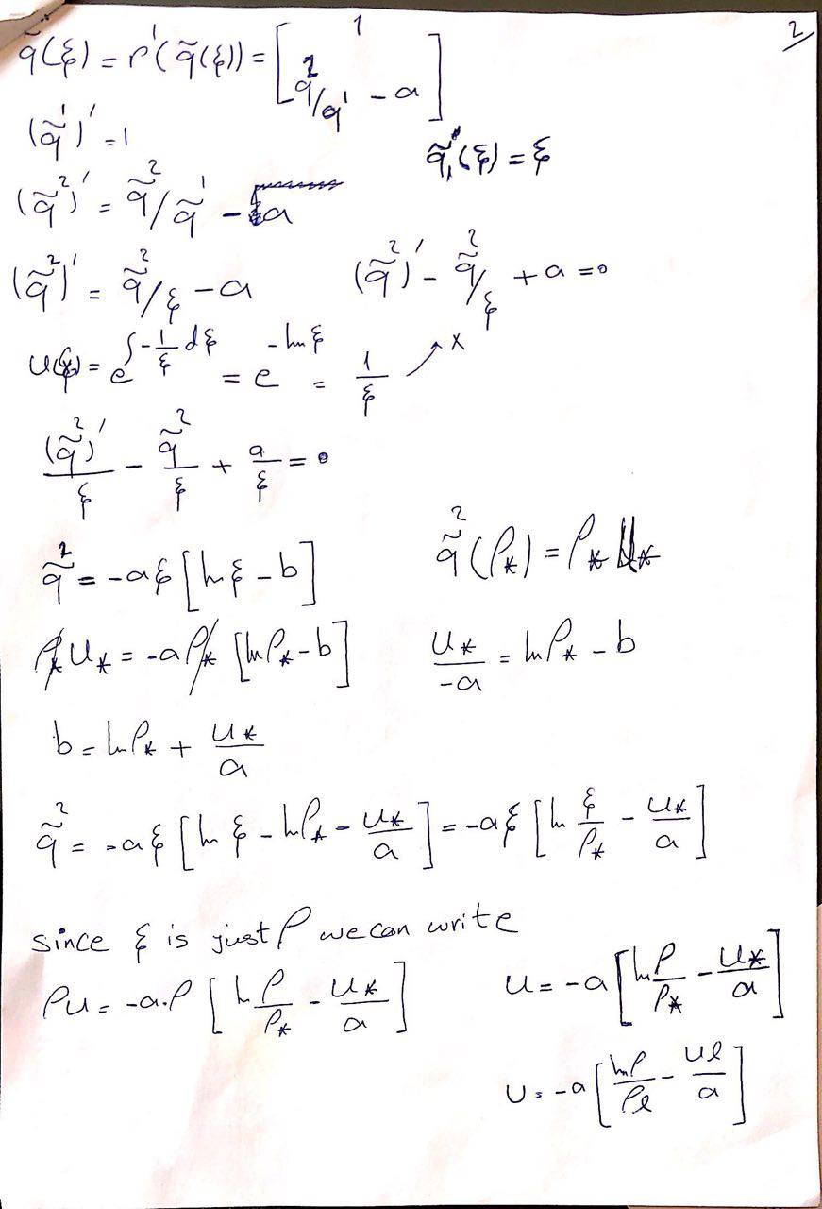  
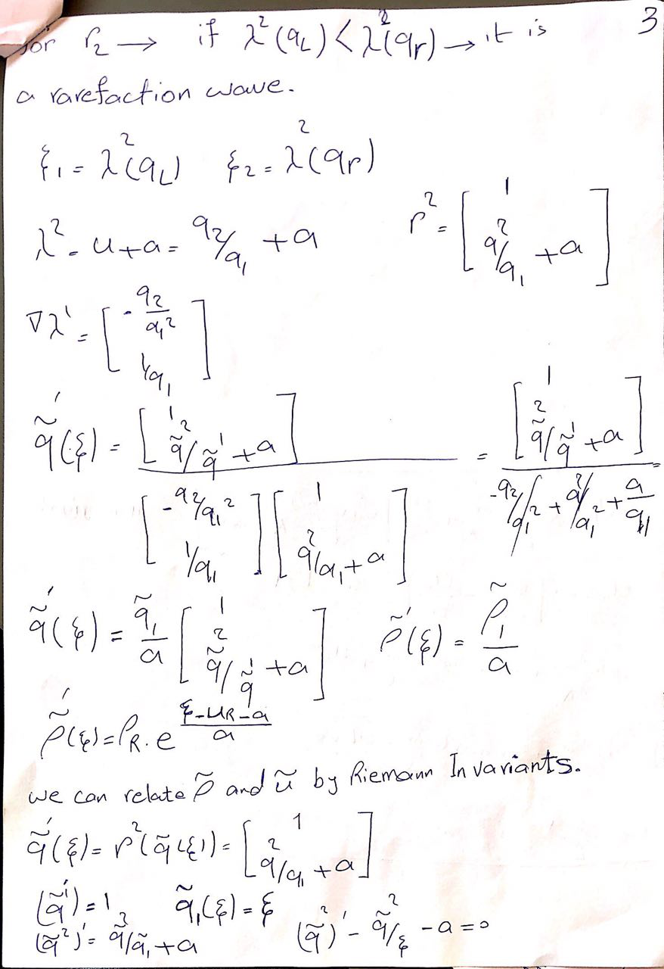  
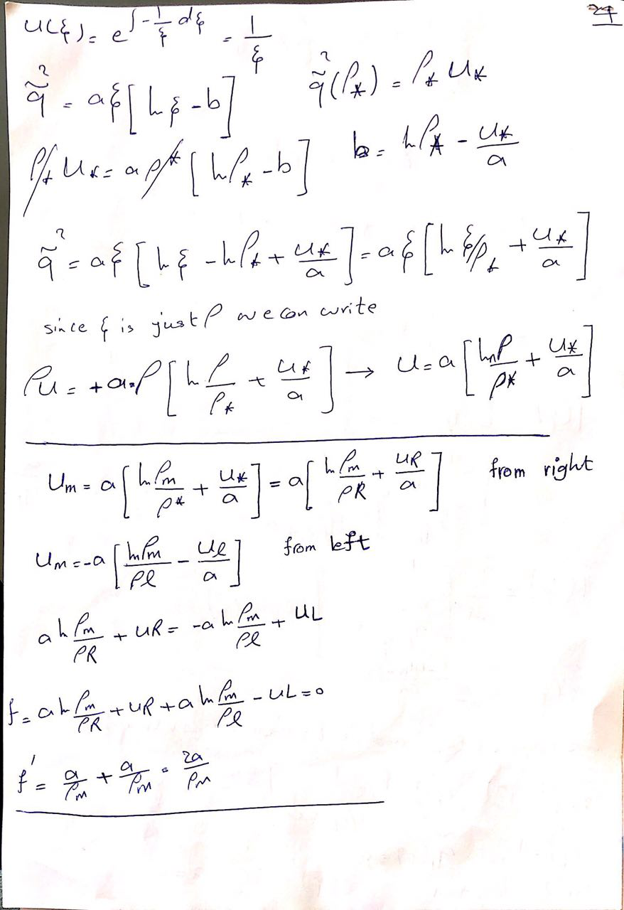

The computer simulation for all rarefaction wave is as below:

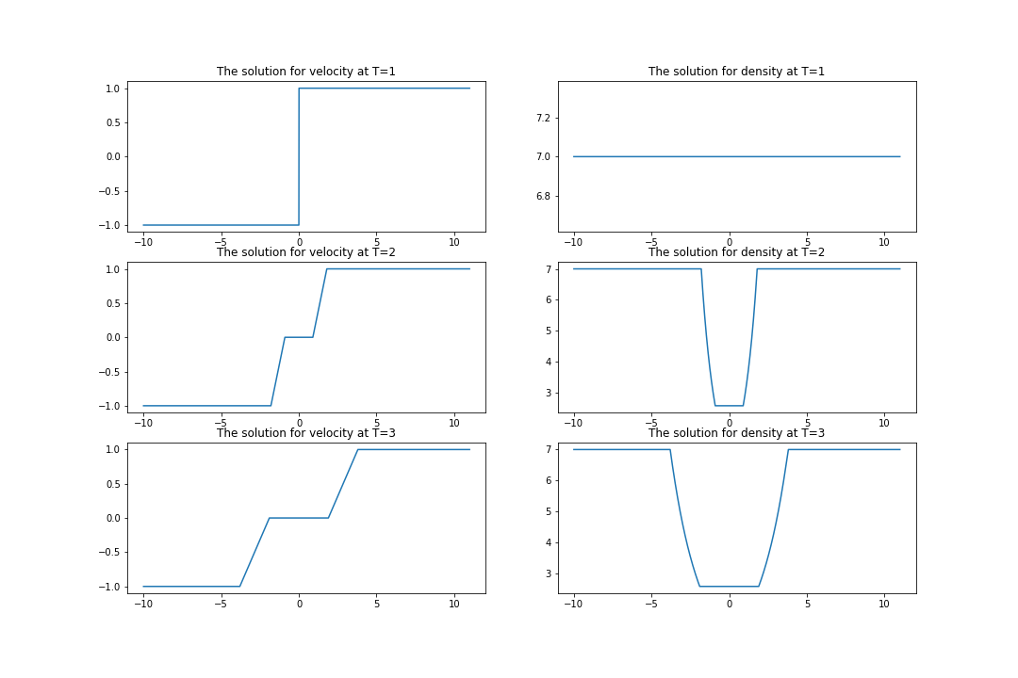This figure is corresponded for UL=-1, UR = 1 , rho_R = rho_L=7 , a=1 , delta t = 0.5 and delta x = 0.01 .